Task4:

Q: increment the large integer by one and return the resulting array of digits.

Analysis:

* Take array of digits, initialize the carry value by 1
* Loop the array left to right
* Add carry to the last digit
* If the sum is above 9 set the current digit 0 and update to 1
* Return the updated array.

Flow chart:

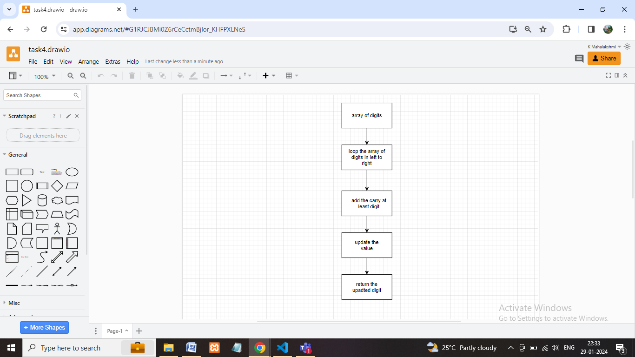

Coding:

function task4(digits)

{

let carry = 1;

for (let i = 0; i < digits.length; i++)

{

if (digits[i] + carry > 9)

{

digits[i] = 0;

carry = 1;

} else {

digits[i] = digits[i] + carry;

carry = 0;

}

}

if (carry)

{

const newdigits=[1];

for (let i = 0; i < digits.length; i++)

{

newdigits.push(digits[i]);

}

return newdigits;

}

return digits;

}

const digits = [1, 2, 3];

console.log("result:", task4(digits));

Output:

